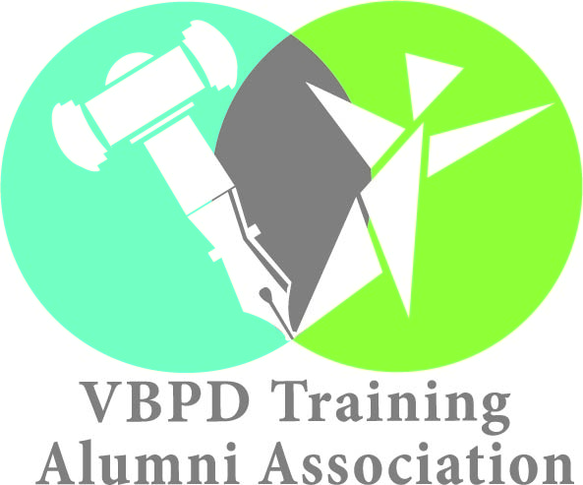

**Frequently Asked Questions**

**About Advocacy Activities for the Alumni Development Program**

General guidance about advocacy activities for the Alumni Development Program is provided below. Please contact Dr. Penni Sweetenburg-Lee at 804-786-9381 or [Penni.Sweetenburg-Lee@vbpd.virginia.gov](mailto:Penni.Sweetenburg-Lee@vbpd.virginia.gov) if you need further assistance.

**What is an advocacy activity?**

An advocacy activity is an activity that promotes the improvement of the disability services system. Improvement may be achieved through expanding or otherwise altering the system. Changes to laws, regulations, or the budget may be needed to bring about improvement.

Advocacy activities can include phone campaigns, letter writing, petitions, written public comment, in-person public comment, meetings with policymakers, and awareness events. Chapters should plan a variety of types of advocacy activities to give members an opportunity to use their differing interests and skill sets.

**What is NOT an advocacy activity?**

Events that the Board does not consider to be advocacy activities include, but are not limited to, the following:

* Activities that do not promote the improvement of the services system for people with developmental disabilities;
* Activities that solely involve advocating for oneself, rather than advocating on behalf of others e.g., attending a resource fair solely to receive educational information;
* Activities that are primarily social activities, including entertainment such as going to the movie theater; and
* Activities that are solely to raise money for other advocacy organizations, and do not involve an educational or advocacy-related component.

Chapter members may participate in the above activities, if desired. However, they will not be supported by Board funding nor count towards the required number of advocacy activities.

**Can the advocacy cause be broader than developmental disabilities?**

Chapters can participate in advocacy activities that promote causes that are broader than developmental disabilities as long as the activities

1. address issues that would also benefit people with developmental disabilities, and
2. are the exception rather than the norm in the chapter’s overall calendar of events i.e., majority of activities must focus on the needs of people with developmental disabilities.

Advocacy activities with causes that are broader than developmental disabilities need to be approved by Board staff on a case-by-case basis.

**How do awareness events differ from other advocacy activities?**

Awareness events, such as a Down Syndrome 5k, typically focus on raising awareness among the general public about a broad issue. While awareness events are an important part of advocacy, they are not the only type of advocacy. Other advocacy activities, such as phone campaigns or letter writing, are typically more focused on a specific policy issue, target decision makers as the primary audience, and request specific changes. These other advocacy activities can be more likely to effect change, so chapters should plan a mixture of awareness and non-awareness advocacy events.

There may be ways to make an awareness event more effective at influencing change by incorporating elements from the other types of advocacy activities. For example, members could ask participants at an awareness event to sign a petition for a related issue. Members could also invite legislators or other relevant decision makers to attend the awareness event. At the event, members could give the decision makers educational information with action items so they leave with concrete takeaways.

**Are chapters required to work with other advocacy organizations?**

The Board does not wish to duplicate existing advocacy organizations but rather enhance their effectiveness. Chapters are strongly encouraged to partner or collaborate with other advocacy organizations, including other regional chapters, to leverage resources. See the next question to learn more about what partnering and collaboration entails.

**What does working with other advocacy organizations mean in practice?**

Chapter members may wish to partner with other organizations to co-host an advocacy activity. As a partner, the chapter can help the organization plan a new or ongoing advocacy event. This approach gives the chapter some control over the event’s focus and content, allowing the chapter to incorporate its own advocacy priorities.

Chapter members may alternatively wish to collaborate with other organizations to help make an advocacy activity more successful. The role that chapter members have may depend on the host organization’s needs. Roles may include assistance in marketing the advocacy activity and running the activity on event day. In addition to helping fulfill the other organization’s needs, chapters should make an effort to incorporate their own advocacy priorities into the advocacy activity, to the extent possible.